Department of Computer Science

Lab Manual

of

Tiny MACHINE LEARNING

(MAI524B-5)

Class Name: V MSCAIML

Master of Science Artificial Intelligence and Machine Learning

2026

Prepared by: Verified by:
Satyam Chaturvedi 2548547
Dr. Helen K Joy

Department Overview
Department of Computer Science of CHRIST (Deemed to be University) strives to shape outstanding computer professionals with ethical and human values to reshape nation’s destiny. The training imparted aims to prepare young minds for the challenging opportunities in the IT industry with a global awareness rooted in the Indian soil, nourished and supported by experts in the field.

Vision
The Department of Computer Science endeavours to imbibe the vision of the University “Excellence and Service”. The department is committed to this philosophy which pervades every aspect and functioning of the department.

Mission
“To develop IT professionals with ethical and human values”. To accomplish our mission, the department encourages students to apply their acquired knowledge and skills towards professional achievements in their career. The department also moulds the students to be socially responsible and ethically sound.

Introduction to the Programme
Master of Computer Applications (MCA) is a post-graduate programme of CHRIST (Deemed to be University) and approved by the All India Council of Technical Education (AICTE). It is a two-year programme spread over six trimesters to bridge the chasm between computer studies and applications, bringing within reach of enthusiastic youngsters an excellent group of experienced and dedicated staff and experts, and an enviable infrastructure. MCA at CHRIST (Deemed to be University) strives to shape outstanding computer professionals with ethical and human values to reshape the nation’s destiny. The training programme aims to prepare young minds for challenging opportunities in the IT industry with a global awareness rooted in the Indian soil, nourished and supported by experts in the field. The Department is committed to the motto “Excellence and Service,” and this philosophy pervades every aspect of its functioning.

Programme Objective
This programme is conceptualised and designed based on the strong commitment of the
department to provide better quality education to the students. The principal objectives of this
course are to:
● Heighten technological awareness
● Train future industry specialists
● Encourage effective software development
● Provide research training
● Involve students in innovative research
● Produce graduates with a two-year professional education in Computer Science with
technical, professional, and communications skills.

Ethics and Human Values
1. Only proprietary or open-source software would be used for academic teaching and
learning purposes.
2. Copying of programs from the internet, friends or from other sources is strictly
discouraged since it impairs development of programming skills.
3. Unique Practical (Domain based) exercises ensure that the students don’t get involved in
code plagiarism.
4. Projects undertaken by students during the course are done in teams to improve
collaborative work and synergy between team members.
5. Projects involve modularization which initiates students to take individual responsibility
for common goals.
6. Passion for excellence is promoted among the students, be it in software development or
project documentation.
7. Giving due credit to sources during the seminar and research assignment is promoted
among the students
8. The course and its design enforce the practice of good referencing technique to improve
the sense of integrity.
9. Courses involving group discussions and debates on ethical practices and human values
are designed to sensitize the students in dealing with customers and members within the
Organization.

Programme Outcomes:
PO1 : Conduct investigation and develop innovative solutions for real world problems in industry and research establishments related to Artificial Intelligence and Machine Learning PO2 : Apply programming principles and practices for developing automation solutions to meet future business and society needs.
PO3 : Ability to use or develop the right tools to develop high end intelligent systems
PO4 : Adopt professional and ethical practices in Artificial Intelligence application development
PO5 : Understand the importance and the judicious use of technology for the sustainability of the environment.

Programme Educational Objectives(PEO’s)
PEO1: Develop innovative and effective software solutions through research that addresses
real-world challenges, grounded in a commitment to continuous learning and adaptability.
PEO2: Advance the knowledge and practices in the field of computer applications through
lifelong learning and rigorous research, supporting professional growth and academic excellence.
PEO3: Exhibit ethical leadership, social responsibility to contribute and enhance community
well-being by innovating solutions.

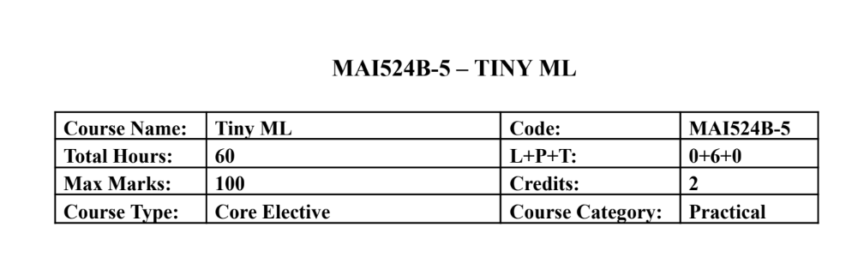Course Description
This course focuses on hands-on development of TinyML applications on mobile, edge, and
embedded platforms. Students learn the end to end workflow including data preparation,
lightweight model development, optimization, and deployment on microcontrollers using
sensors. Emphasis is placed on practical implementation using TensorFlow Lite, TensorFlow Lite
Micro, and embedded development environments with minimal theory and extensive laboratory
work.
Course Objectives
This course introduces the TinyML development workflow for edge intelligence and builds
practical skills in model optimization and embedded deployment. It enables students to develop
audio, vision, and sensor based TinyML applications and implement real time intelligent systems
using microcontrollers and hardware sensors.

Course Outcomes
CO1: Design TinyML workflows and lightweight models for edge devices.
CO2: Implement TensorFlow Lite-based optimisation and deployment.
CO3: Develop keyword spotting and visual TinyML applications.
CO4: Deploy sensor based TinyML solutions on embedded hardware.
CO5: Build end to end practical TinyML systems integrating hardware

Unit-1 Teaching Hours: 12
TINYML FOUNDATIONS AND WORKFLOW DESIGN
TinyML ecosystem overview – edge AI concepts – machine learning lifecycle – sensor roles in
TinyML – dataset planning – development environment setup – lightweight application
workflow design.Edge Computing vs Cloud Computing: A Comparative Demonstration of On
Device and Remote AI Inference
Practical Exercises:
1. Sensor data exploration and TinyML workflow planning using Colab.
2. Design and simulation of a TinyML application pipeline including preprocessing and
inference stages.

Unit-2 Teaching Hours: 12
TENSORFLOW LITE AND MODEL OPTIMIZATION
TensorFlow Lite workflow – model conversion – inference pipelines – low precision
computation – post training quantization – quantization aware training – performance
benchmarking.Human Activity Recognition Using Accelerometer and Multisensor Data
Practical Exercises:
3. Convert TensorFlow models to TensorFlow Lite and perform inference evaluation.
4. Implement quantization techniques and compare accuracy, latency, and memory usage.

Unit-3 Teaching Hours: 12
AUDIO TINYML AND KEYWORD SPOTTING
Keyword spotting architecture – audio preprocessing – MFCC and spectrogram features –
dataset preparation – training workflow – streaming audio inference.
Practical Exercises:
5. Train a keyword spotting model using speech datasets in Colab.
6. Deploy and test keyword spotting inference using live or recorded audio input.

Unit-4 Teaching Hours: 12
Visual Wake Words and Anomaly Detection
Visual wake word applications – transfer learning – lightweight vision models – anomaly
detection concepts – autoencoders and clustering – responsible dataset handling.Deploying a
Lightweight MLP and 1D CNN on Embedded Targets: Challenges and Performance Analysis
Practical Exercises:
7. Develop a visual wake word model using transfer learning techniques.
8. Build an anomaly detection system using sensor or industrial datasets.

Unit-5 Teaching Hours: 12
Embedded Deployment with TensorFlow Lite Micro
Microcontroller basics – embedded ML workflow – TensorFlow Lite Micro interpreter –
memory allocation – sensor integration – real time inference – deployment practices.
Practical Exercises:
9. Deploy a pretrained TinyML model on Arduino Nano 33 BLE Sense or equivalent
board.
10. Develop an integrated TinyML application such as gesture recognition, sensor anomaly
detection, or embedded keyword spotting.

Text & Reference Books
[1] TinyML, Pete Warden and Daniel Situnayake, O Reilly Media, First Edition, 2019
[2] Deep Learning with Python, Francois Chollet, Manning Publications, Second Edition,
2021
Essential Reading
[1] TinyML Cookbook, Gian Marco Iodice, Packt Publishing, First Edition, 2022
[2] Practical Edge AI, O Reilly Media, First Edition, 2023
Additional Information (Web Resources):
1. TensorFlow Lite Documentation: https://www.tensorflow.org/api_docs/python/tf/lite
2. TensorFlow Lite Micro GitHub Repository: https://github.com/tensorflow/tflite-micro
3. Arduino TinyML Tutorials:
https://docs.arduino.cc/tutorials/nano-33-ble-sense/get-started-with-machine-learning/
4. Edge Impulse TinyML Labs: https://www.edgeimpulse.com/
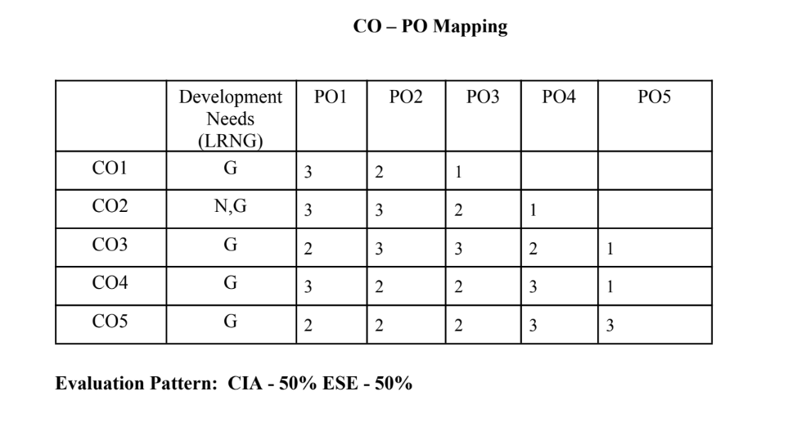

LIST OF PROGRAMS

MSCAIML
Sl.no | Title of lab Experiment | Page number | RBT | CO
1 | Real-Time Rotational Dynamic & Edge-AI Payload Safety System |  | L3 | CO1,3
2 | Real-Time Rotational Dynamic & Edge-AI Payload Safety System |  | L3 | CO2,3
3 | Multi-Class Human Activity Recognition & Model Quantization Scheme Analysis |  | L3 | CO3
4 | Quantization Aware Training (QAT) |  | L3 | CO3
5 | Voice Emergency Stop |  | L3 | CO3
6 | Voice Emergency Stop with Live Audio |  | L3 | CO3,4
7 |  |  | L4 | CO3
8 |  |  | L3 | CO3,4
9 |  |  | L3 | CO4,5
10 |  |  | L5 | CO5

Evaluation Rubrics:
Evaluation Rubrics for each program would be
EVALUATION RUBRICS
(R1) Concept Clarity (Viva) - 3 M
(R2) Code Execution - 3M
(R3) Complexity Addition (Self Learning) -2 M
(R4) Timely Submission - 2 M

Submission Guidelines:
- Make a copy of the lab manual template with your <name_reg:no_subject name >,
- Copy the given question and the answer (lab code) with results, followed by the conclusion of that lab. Title the lab as lab number.
- Keep updating your lab manual and show the lab manual of that particular lab for evaluation.
- Create a Git Repository in your profile <tiny_ML_lab-reg no> . Follow a different branch for each lab <Lab 1, Lab 2…>, and push the code to Git. The link should be provided in Google Classroom along with the PDF of the lab manual.
- Upload the PDF to Google Classroom before the deadline.

Lab 1 Question: Real-Time Rotational Dynamics & Edge-AI Payload Safety System

Tools Required: Smartphone with phyphox app, flat rotating platform, small test payload (e.g., coin or eraser), Python 3.x (Google Colab / Jupyter).

1. Aim
To measure tri-axial angular velocityusing a smartphone's gyroscope via phyphox, derive the physical threshold for rotational static friction failure, extract time-series features, and build an optimized TinyML classification model to predict payload stability (SAFE vs. UNSAFE/FALL) on an edge device.

2. Scenario & Problem Statement
An autonomous warehouse mobile robot carries an unanchored payload on its top surface. A smartphone mounted to the chassis acts as the primary Inertial Measurement Unit (IMU). When the robot negotiates sharp turns at high angular speeds, centripetal forces exceed static friction, causing cargo to slide off.
Your Task:
- Physical Setup: Place a test object on the smartphone screen
- Data Acquisition: Use phyphox to log gyroscope data while gradually increasing tilt and rotation speed until the object slides off.
- Data Engineering: Process raw CSV data
- Edge ML Pipeline: Label windowed data into binary classes (0 = SAFE, 1 = UNSAFE/FALL), train a lightweight classifier, and quantize it to .tflite format for local edge execution.

3. Submission Deliverables
- Workflow of the problem.
- Raw Dataset: Exported phyphox_gyro_data.csv.
- Python Code Script and git repo : Complete pipeline covering feature extraction, threshold determination, model training, and .tflite export.
- Lab Report: Experimental coefficient of static friction ($\mu_s$), model confusion matrix, and TFLite model size footprint in kilobytes.

Evaluation Rubric (10 Marks Total)
Assessment Module | Performance Criteria | Marks
1. Data Acquisition & Preprocessing | • Proper experimental setup and clean data collection.  • Correct signal processing, normalization, and feature engineering. | / 3
2. Implementation & Model Optimization | • Correct implementation of baseline models and algorithms.  • Successful execution of optimization, quantization, or deployment pipelines. | / 3
3. Results Analysis, Code & Deliverables | • Complete benchmarking/results analysis (accuracy, memory, speed, or system metrics).  • Clean, well-documented code with a clear final technical report. | / 4

Workflow of the problem.
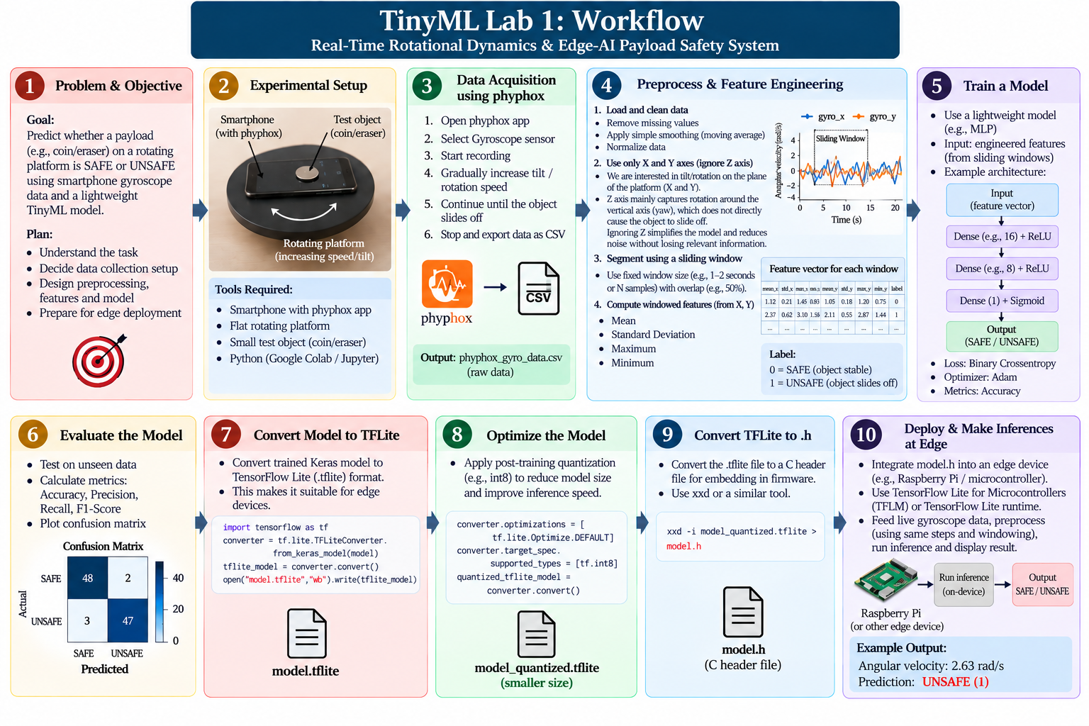

Lab 2 Question: Multi-Class Human Activity Recognition & Model Quantization Scheme Analysis

1. Aim
To collect multi-axis accelerometer motion data for three distinct activity classes (Idle, Walking, and Sit-ups) using phyphox, train a 3-class Human Activity Recognition (HAR) classifier, implement three TensorFlow Lite model quantization techniques, and systematically benchmark their effects on memory footprint, execution speed, and classification accuracy.

2. Scenario:
You are an Embedded AI Engineer designing an activity-tracking algorithm for an ultralow-power wearable device. The device must run on-device inference to classify physical activity states (Idle/Static, Walking/Locomotion, and Sit-ups/Repetitive Exercise) without sending raw sensor streams to the cloud. Before deploying the model to hardware, you are tasked with conducting an optimization study comparing the trade-offs between accuracy retention, RAM/ROM footprint, and execution speed across different quantization paradigms.

Your Task:

- Data Acquisition: Secure your smartphone against your chest or waist. Use phyphox > Accelerometer (or Linear Acceleration) to collect sensor streams for three distinct activity states: Idle/Sitting, Walking, and Sit-ups. Export the raw files as idle.csv, walking.csv, and situps.csv.

- Feature Extraction & Processing: Segment continuous acceleration streams into 1-second window intervals (100 samples/sec). Compute the 3D acceleration vector magnitude:

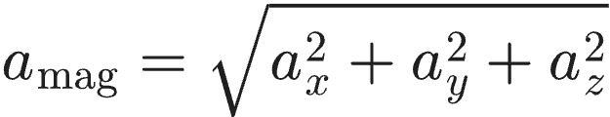
- Extract statistical features per window interval:

Mean Acceleration ():

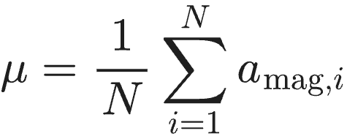

Standard Deviation ():

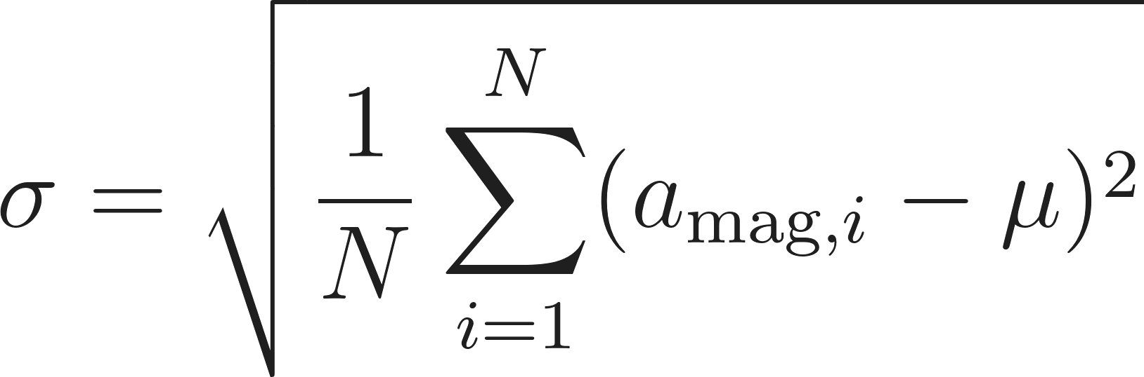
Root Mean Square ():

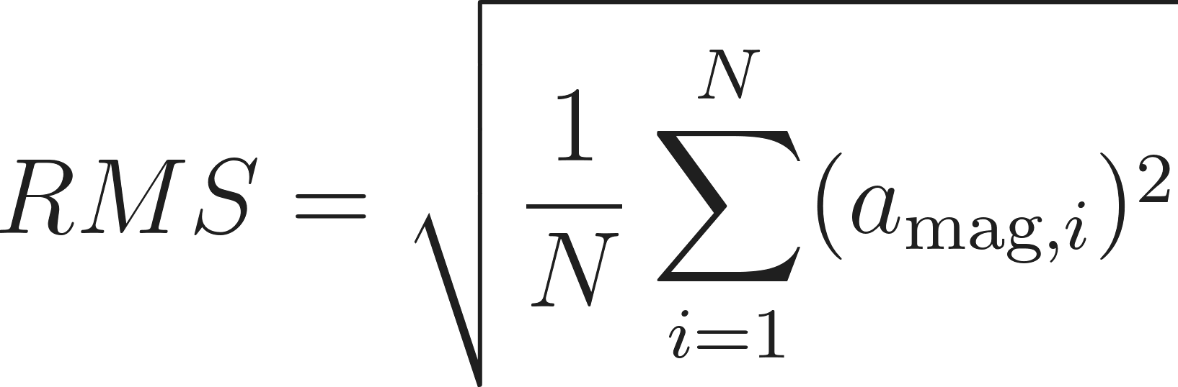
- Model Development: Train a baseline 3-class Multi-Layer Perceptron (MLP) neural network in Python / Google Colab using the extracted feature matrices.

- Quantization Comparison Experiment: Convert the baseline model into four distinct TensorFlow Lite variants:
Variant A: Unquantized Baseline (Float32)

Variant B: Dynamic Range Quantization (Weights quantized to int8, activations in float32)

Variant C: Float16 Quantization (Weights converted to 16-bit float)

Variant D: Full Integer Quantization (Weights and activations strictly quantized to int8 using a representative calibration dataset)

- Comparative Analysis: Benchmark all four variants on the test dataset and record model file sizes (in KB), test classification accuracy (%), memory reduction (%), and average inference execution time () per window.

3. Submission Deliverables
- Raw Datasets and work flow diagram : idle.csv, walking.csv, and situps.csv collected via phyphox.
- Python Script: Complete pipeline implementing windowing, 3-class model training, generation of all 4 TFLite quantisation variants, and automated latency/memory benchmarking.
- Quantisation Benchmarking Report: Completed evaluation table and analysis explaining why full integer quantisation is required for microcontroller deployment.

4. Benchmarking Results Table (To Be Completed by Student)
Quantization Scheme | Target Data Type | Model Size (KB) | Accuracy (%) | Memory Reduction (%)
Baseline (Unquantized) | Float32 | Baseline | Baseline | 0.0%
Dynamic Range | Weights int8, Act float32
Float16 Quantization | Float16
Full Integer (PTQ) | Weights int8, Act int8

5. Evaluation Rubric (10 Marks Total)

Assessment Module | Performance Criteria | Marks
1. Data Acquisition & Preprocessing | • Proper experimental setup and clean data collection.  • Correct signal processing, normalization, and feature engineering. | / 3
2. Implementation & Model Optimization | • Correct implementation of baseline models and algorithms.  • Successful execution of optimization, quantization, or deployment pipelines. | / 3
3. Results Analysis, Code & Deliverables | • Complete benchmarking/results analysis (accuracy, memory, speed, or system metrics).  • Clean, well-documented code with a clear final technical report. | / 4
TOTAL SCORE: _____ / 10 MARKS

Workflow of the problem.
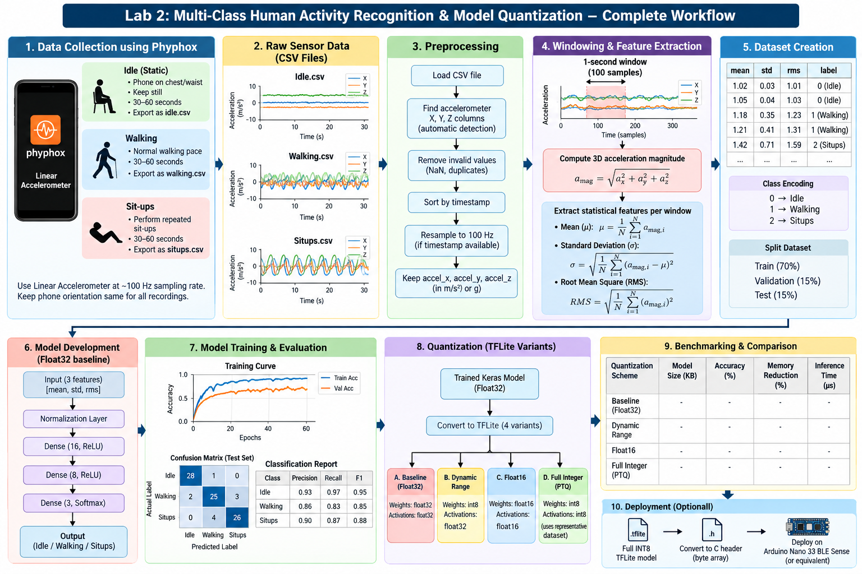

Lab 4 Question: Quantization Aware Training (QAT)
Aim
To implement Quantization-Aware Training (QAT) on a TinyML model, using either motion-sensor data collected with the Phyphox app or a standard image dataset with MobileNetV2, and to compare it with Post-Training Quantization (PTQ).

Objectives
- Prepare input data from Phyphox sensor recordings or from a standard image dataset.
- Train a baseline model and apply full INT8 Post-Training Quantization.
- Apply Quantization-Aware Training and convert the model to full INT8 TensorFlow Lite.
- Compare the models in terms of accuracy, size and latency.

Lab Setup
Run the following as the first cell in a fresh Colab runtime:
!pip install -q tensorflow-model-optimization tf_keras
import os
os.environ["TF_USE_LEGACY_KERAS"] = "1" # set before importing tensorflow
import tensorflow as tf
import tensorflow_model_optimization as tfmot

Procedure
- Input data: choose one option.
  - Option A (sensor data): Using Phyphox, record four motion classes of your choice (for example: still, walking, shaking and circular motion) for about 60 seconds each. Export each recording as a CSV file and upload it to Colab.
  - Option B (image data): Load the CIFAR-10 dataset from tf.keras.datasets. Use a subset (for example, 5,000 training and 1,000 test images) resized to 96 × 96 pixels.
- Preprocessing: Option A: label and combine the CSV files, segment the signal into fixed-length windows, normalise, and split into training and test sets. Option B: scale the images as required by MobileNetV2.
- Baseline model: Option A: train a small Keras model. Option B: build a MobileNetV2 model (pre-trained on ImageNet, alpha = 0.35) with a new classification head, as a single functional model (not nested), and fine-tune it. Record the test accuracy.
- Post-Training Quantization: Convert the baseline model to a full INT8 TFLite model using a representative dataset, and evaluate it with the TFLite interpreter.
- Quantization-Aware Training: Apply QAT to the trained baseline model, fine-tune it, convert it to a full INT8 TFLite model, and evaluate it.
- Comparison: Record the results in the table below.
Model | Size (KB) | Test accuracy (%) | Avg latency (ms)
Float32 baseline
PTQ full INT8
QAT full INT8

Questions
- Why does Post-Training Quantization reduce model accuracy?
- What does QAT simulate during training, and how does this help the model?
- Was a representative dataset required to convert the QAT model? Justify your answer.
- Did QAT change the size of the INT8 model? Explain.
- Under what conditions is PTQ sufficient, so that QAT is not needed?

Result
State your conclusion on the effectiveness of QAT compared with PTQ, citing values from your comparison table.
Planned workflow .
Deliverables: the Colab notebook with all outputs, the Phyphox CSV files (Option A only), and the three .tflite models.

Evaluation Rubric
Component | Marks
Workflow +Data collection and preprocessing | 3
Baseline model and PTQ | 3
QAT, conversion and evaluation+Comparison table and result | 2
Questions | 2
Total | 10

Workflow
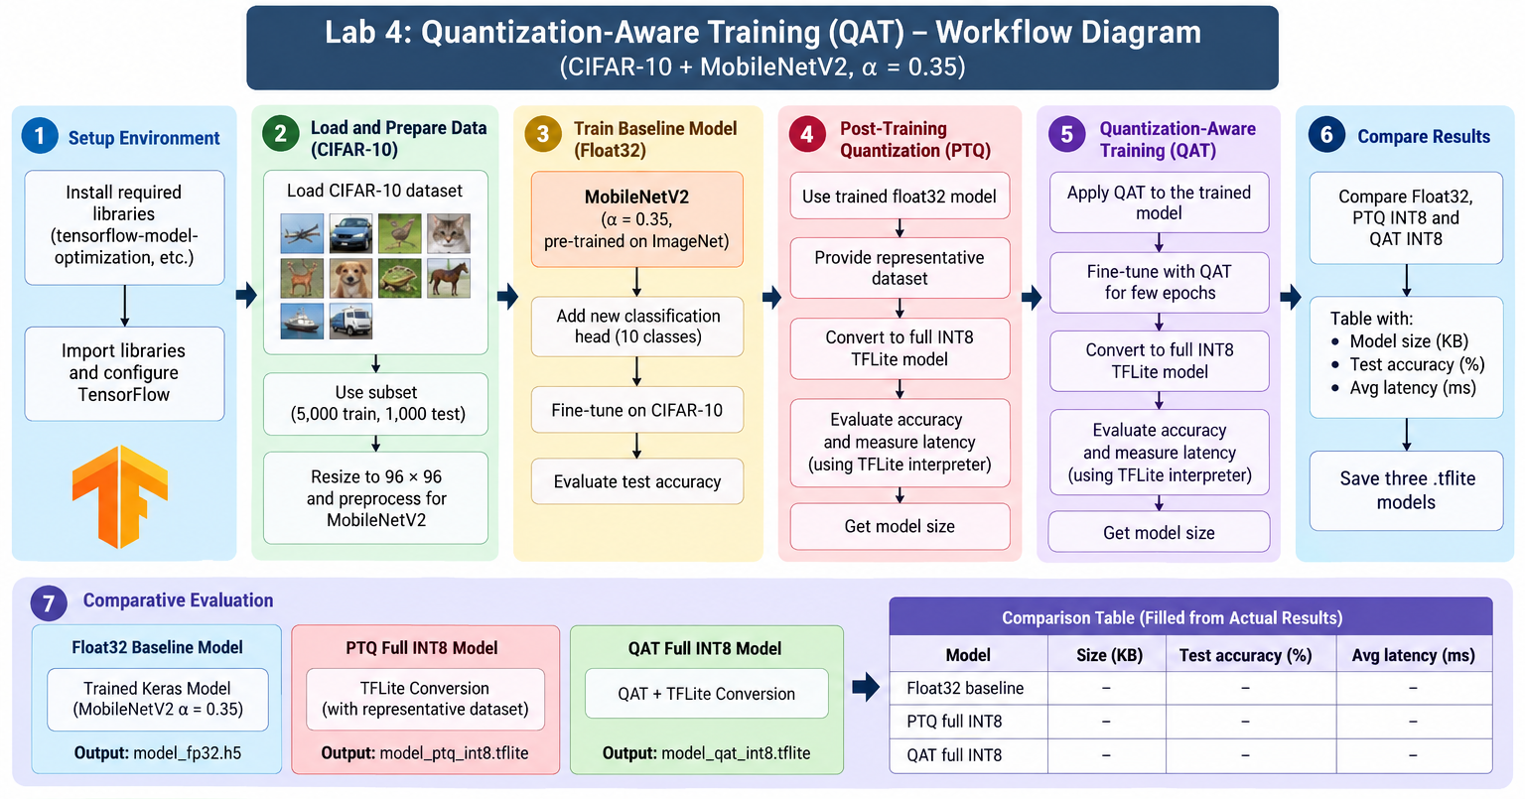

Lab 5: "Shout STOP!" — build the brain of a voice emergency stop
Aim
To train a keyword spotting model in Google Colab that detects the word "stop", using the Google Speech Commands dataset, MFCC features and a DS-CNN.
Objectives
- Prepare a dataset with the classes stop, _unknown_ and _silence_.
- Preprocess audio and extract spectrogram and MFCC features.
- Train and evaluate a DS-CNN keyword spotting model.
- Convert the model to int8 TensorFlow Lite for a microcontroller.
The problem
SafeLine Packaging Pvt. Ltd. runs a fast conveyor belt in Bengaluru. Last month a worker's glove got caught in the rollers. The red emergency button was 4 metres away, and it took 6 seconds to reach it. Nobody was badly hurt, but the safety officer was clear: "Next time, the worker must be able to just shout STOP and the belt must halt."
The company cannot send audio to the cloud. The factory Wi-Fi drops often, a cloud delay could cost a finger, and the workers do not want their talk recorded. The solution must run on a tiny microcontroller fixed on the machine, with less than 100 KB of memory for the model.
You are the TinyML engineer. Before buying any hardware, the manager wants proof in Google Colab that a small model can tell "stop" apart from every other word and from machine noise. You will use the Google Speech Commands dataset (Mini Speech Commands): 8 words, about 1,000 one-second clips per word, 16 kHz, many speakers.
Download link: http://storage.googleapis.com/download.tensorflow.org/data/mini_speech_commands.zip
Your tasks
- Collect the evidence (dataset preparation). Workers talk all day, saying "go", "no", "left", "yes". The belt must react only to "stop". Build 3 classes from the dataset:
  - stop: all clips from the stop folder
  - _unknown_: random clips from the other 7 words, the same number as stop
  - _silence_: 1 s background-noise clips, the same number as stop
- Split the data 80/10/10 by speaker, so your test uses voices the model has never heard. New workers join every month.
- Make the audio ready (preprocessing). Load every clip as 16 kHz mono, exactly 1 second. Cut it into frames with a 30 ms window and 20 ms hop.
- Show what the machine "hears" (features). Plot the waveform, spectrogram and MFCC (49 × 10) for a "stop" clip and a "go" clip. Explain to the manager, in 3 lines, why the MFCC pictures look different.
- Design the brain (KWS architecture). Build a small DS-CNN with MFCC input and a 3-class output. Report its parameters. Will it fit in under 100 KB?
- Teach it (training workflow). Train with augmentation: time shift for workers who speak early or late, and background noise for a loud factory. Plot the accuracy and loss curves.
- Safety check (evaluation). Report test accuracy and the confusion matrix. The safety officer wants two numbers:
  - Misses: how many "stop" words did the model not catch? (Dangerous: the belt keeps running.)
  - False alarms: how many other words did it wrongly call "stop"? (Costly: the line halts for no reason.)
- Make it fit the chip (deployment preparation). Convert to int8 TFLite. Compare float and int8 size and accuracy, and export kws_int8.tflite and kws_config.json for Lab 6.
Expected results
- A balanced dataset table across train, validation and test
- MFCC plots where "stop" shows a clear pattern different from "go"
- Test accuracy of about 85–95% on unseen speakers
- Miss and false-alarm counts reported from the confusion matrix
- int8 model of about 45–50 KB (it fits the 100 KB limit), with less than 1% accuracy loss

Criterion | Marks | Full marks when
Dataset preparation and features | 3 | 3 balanced classes from Speech Commands, speaker-wise split, correct waveform, spectrogram and MFCC plots with explanation
Model training and safety evaluation | 3 | Model trains properly; curves, accuracy, confusion matrix, misses and false alarms reported
Quantisation, analysis and viva | 4 | int8 model under 100 KB, float vs int8 compared, safety trade-off explained, viva answered
Rubric (10 marks)

WORKFLOW
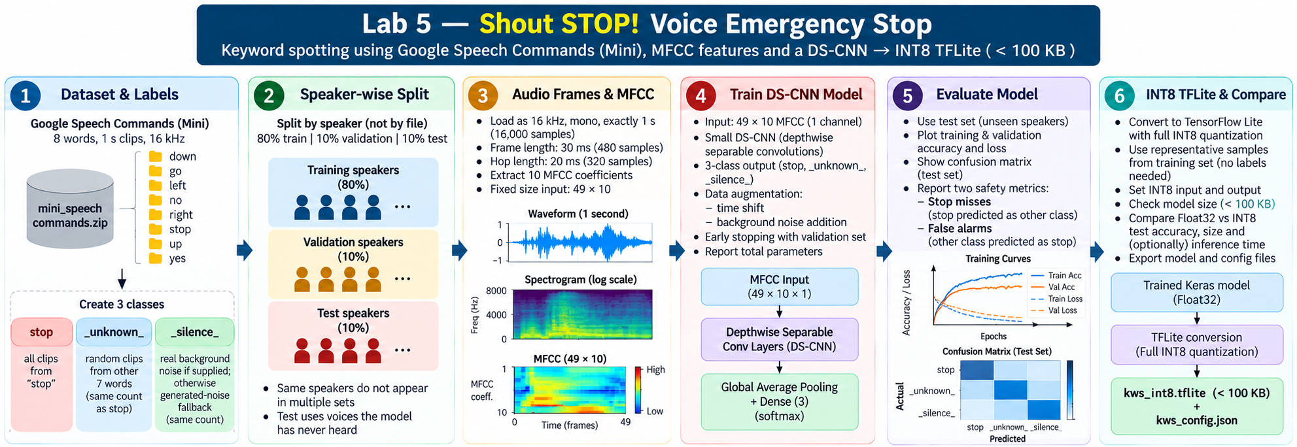

Lab 6: "Field trial" — test the voice emergency stop on the factory floor
Aim
To deploy the int8 "stop" model from Lab 5 (trained on the Google Speech Commands dataset) and test it with recorded and live audio using streaming inference.
Objectives
- Run int8 TFLite inference with the same MFCC front-end as in training.
- Test the model with dataset clips, recorded audio and live microphone audio.
- Implement streaming inference with a sliding window, smoothing, a threshold and a refractory period.
- Measure misses, false alarms, model size and inference time.
The problem
Your Lab 5 model impressed the manager. Now comes the field trial. The safety officer will not accept test-set accuracy. She says: "Clean recordings from a dataset are not my factory. Show me it works with our workers' voices, from a distance, with the machine running. And it must listen all the time; nobody will press a button before shouting stop."
Your job: turn the model into a working voice emergency stop system in Google Colab. Every time "stop" is detected, the screen must show "🛑 BELT STOPPED". Every other word and every machine sound must be ignored.
Your tasks
- Install the brain (load the model). Load kws_int8.tflite and the MFCC settings from kws_config.json (16 kHz, 30 ms window, 20 ms hop, 49 × 10 MFCC). Print the input and output shape, the data type and the quantisation scale, so the hardware team knows what the chip will receive.
- Bench test (dataset clips). Run 15 unseen clips from the Google Speech Commands dataset (5 stop, 5 unknown, 5 silence) and report the prediction and confidence for each.
- Workers' voices (recorded audio). Workers sent voice notes from their phones. Record 10 clips yourself (5 "stop" and 5 other words, including tricky ones like "top", "shop", "go"). Upload them and report what the system does with each.
- Live trial (microphone). Using the laptop mic in Colab, shout "stop" 10 times and say other words 10 times. Fill in a table of correct stops, missed stops and false stops.
- Always listening (streaming inference). Record a 15–20 s clip of a "work shift": normal talk, pauses and "stop" said 3–4 times. Make the system listen continuously:
  - a 1 s window, updated every 100 ms
  - the average of the last 3 predictions (no flicker)
  - a threshold of 0.7
  - a 1 s refractory period (one shout = one stop)
- Plot the audio with each "🛑 BELT STOPPED" marked, and the "stop" score over time.
- Safety vs. production (threshold tuning). The safety officer wants zero missed stops. The production manager hates false stops, because each one costs money. Run step 5 with thresholds of 0.5, 0.7 and 0.9, compare misses and false stops, and recommend one threshold with a reason.
- Will it fit the chip? (performance). Report the int8 model size (KB), the inference time per window (ms) and the MFCC time for 1 s of audio (ms).
- Real factory conditions (robustness). Repeat the live test from 1 m away and with background noise (play machine or fan sound). Compare with Lab 5 test accuracy and explain the difference to the manager.
Expected results
- Model details printed: input 1 × 49 × 10 × 1 int8, output 3 classes
- Bench test: about 13–15 of 15 correct
- "🛑 BELT STOPPED" appears when "stop" is spoken; other words and noise are ignored
- Live table: most stops caught; words like "top" or "shop" may cause a few false stops
- Streaming plot: each "stop" detected once, close to when it was said
- Threshold comparison: a lower threshold gives fewer misses but more false stops; a sensible pick is around 0.5–0.7 for safety
- Model about 45–50 KB, inference under 1 ms per window in Colab
- Accuracy from a distance or with noise a little lower than Lab 5, explained by the different microphone, noise and voice
Rubric (10 marks)
Criterion | Marks | Full marks when
Model loading, bench and recorded tests | 3 | Model loads with matching MFCC settings; dataset and phone clips tested; predictions and confidence reported
Live and always-listening system | 3 | Live table filled; streaming detects each "stop" once and shows "🛑 BELT STOPPED", with the plot
Threshold recommendation, performance and viva | 4 | Thresholds compared, a recommendation justified for safety vs production, size and latency reported, robustness explained, viva answered

Workflow Diagram


